Wildlife in Need Center
Juvenile Limits for 2021 Season

Wildlife in Need Center has established limits for our orphan care and rehabilitation program for common species. This is meant to manage patient numbers with consideration for our staff and caging resources as well as for the quality of care for our animals. Species limits may be adjusted mid-season as agreed by the DAC and AC staff. Mid-season adjustments to established limits should be based on age specific success/failure as well as overall resources and patient load.

Eastern Cottontail Rabbits – Eyes Open or Peeping

Recommendation:
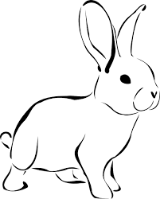
- Focus on rabbits that are admitted with their eyes peeping or open (8-10 days of age in the wild)
- Refer out or humanely euthanize rabbits less than 8 days of age
- Age based exceptions may be made by AC staff with photo review
- Always make every effort to refer eyes closed animal before admission
- Triage any animal with chronic GI symptoms when patient load is high (i.e., Any rabbits that with unimproved bloat or diarrhea for more than 48 hours should be euthanized )
- Triage any animal with skull or jaw injuries that may impact jaw alignment (i.e., any rabbits that have injuries that may result in malocclusion and those with injuries that cause severe pain when feeding)

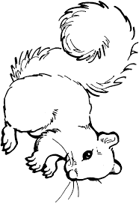
Eastern Gray Squirrels – Eyes Open or Peeping

Recommendation:
- Focus on squirrels over 4 weeks of age
- When possible, refer out any squirrels that do not have eyes open or peeping (developmental marker at 28 days of age)
- Always make every effort to refer eyes closed animal before admission
- Triage any animal with skull or jaw injuries that may impact jaw alignment (i.e., any squirrels that have injuries that may result in malocclusion and those with injuries that cause severe pain when feeding)
- Triage any individual animal with fibromavirus (‘Squirrel Pox’)
  - Exception should be made if there are at least 2 affected individuals and they can be quarantined responsibly

Virginia Opossums – 30g or Related

Recommendation:
- Focus on opossums weighing 30g+ including conspecifics
  - Litters should never be broken up based on weight requirements
  - If one or two individuals in a larger litter are less than 30g, they are to be kept with their group
- Whenever possible, refer out any opossums that look to be younger than 30g (fur smooth and slick, less ‘furry’ in appearance)
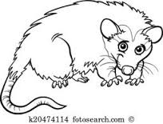

Raccoons

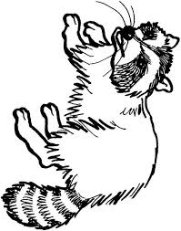
Raccoons under 700g will not be rehabilitated in our current program
Maximum caging capacity for juveniles on-site is 40 animals!
Assessment discretion is critical for this species with current resources
*Limits will be updated regularly as season progresses*

5/21 – Space available for 18 raccoons

Waterfowl

Juvenile native waterfowl may be admitted at any age
