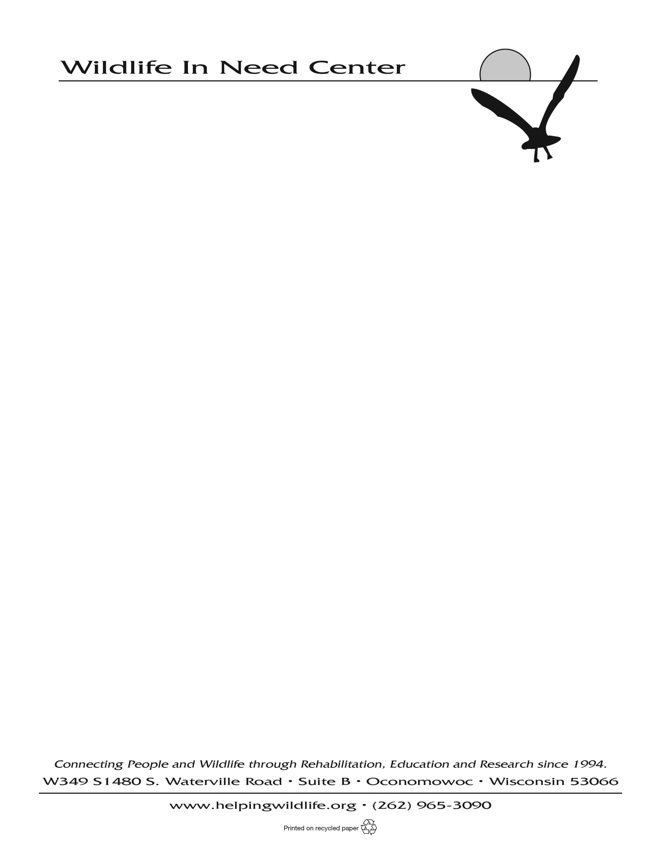
Seasonal Animal Care Staff
2024

General Position Guidelines:
The Seasonal Animal Care Staff assists with the care, treatment, and release of wild patients at the Wildlife in Need Center. This position is 10-20 hours per week for the months of April through October, and reports to the Director of Animal Care.

Position Objectives:
- Quality care and treatment of all wildlife patients.
- Compliance with applicable state and federal regulations.

Primary Responsibilities:
- Assists Animal Care staff with most daily operations including (but not limited to) husbandry, admissions, care and treatment of wildlife in care at WINC.
- Set up and maintain animal caging and enclosures as directed by animal care staff.
- Maintain accurate patient records and ensure that patient charts and care sheets are legible and updated.
- Ensure that protocols for infection/disease control are being followed.
- Assist Animal Care staff with the oversight and training of interns.
- Work with and assist animal care volunteers as needed.
- Adhere to WINC’s animal care policies and procedures.
- Maintain cleanliness and order in all work areas.
- Foster and maintain the wild nature of patients by following WINC policies and procedures.

Additional Responsibilities:
- Provide input on animal care policies and procedures.
- Assist in maintaining accurate records and good relationships with home care/foster volunteers.
- Seek assistance as needed to meet the position objectives, i.e. request specific training or identify a need for specialized equipment/supplies.
- Assist with releases when necessary.
- Must be able to lift/move 50 pounds, endure long workdays in a physically and emotionally demanding setting while maintaining focus, accuracy and physical activities required by the job.

Qualifications:
- Experience in the field of wildlife rehabilitation preferred.
- Ability to work well with other people and as a member of a team.
- Project a positive attitude toward co-workers, supervisor, volunteers and interns.
- Ability to prioritize tasks and complete them in an efficient manner.
- Willingness to work a flexible schedule.
- Continually learn about our diverse patient population and be able to adapt procedures and protocols to support both population-based and individualized care in a high volume setting.

To apply: Please submit a resume, three professional references and cover letter to Elisa Fosco at lfosco@helpingwildife.org. Applications should be submitted ASAP due to the upcoming start date.

The Wildlife in Need Center is an equal employment opportunity organization. We are committed to providing employees with a work environment free of discrimination and harassment. All applicants will be considered without attention to race, color, religion, sex, sexual orientation, marital status, gender identity, national origin, veteran, or disability status.

